create a private hosted zone named "[ttn-internal.com](http://ttn-internal.com/)" attached to the default vpc. and created a cname record "[myloadbalance.ttn-internal.com](http://myloadbalance.ttn-internal.com/)" for any load balancer pointed to its dns.

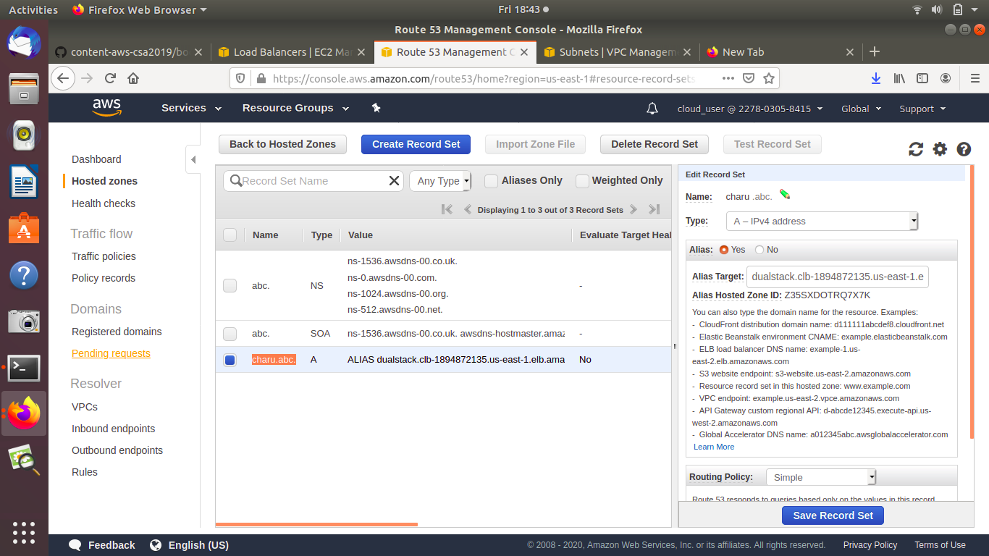

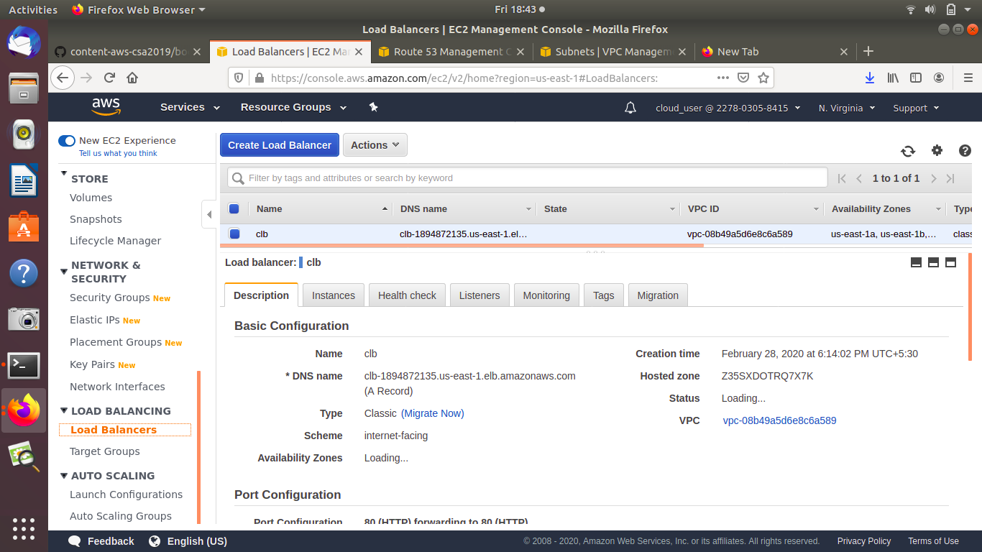

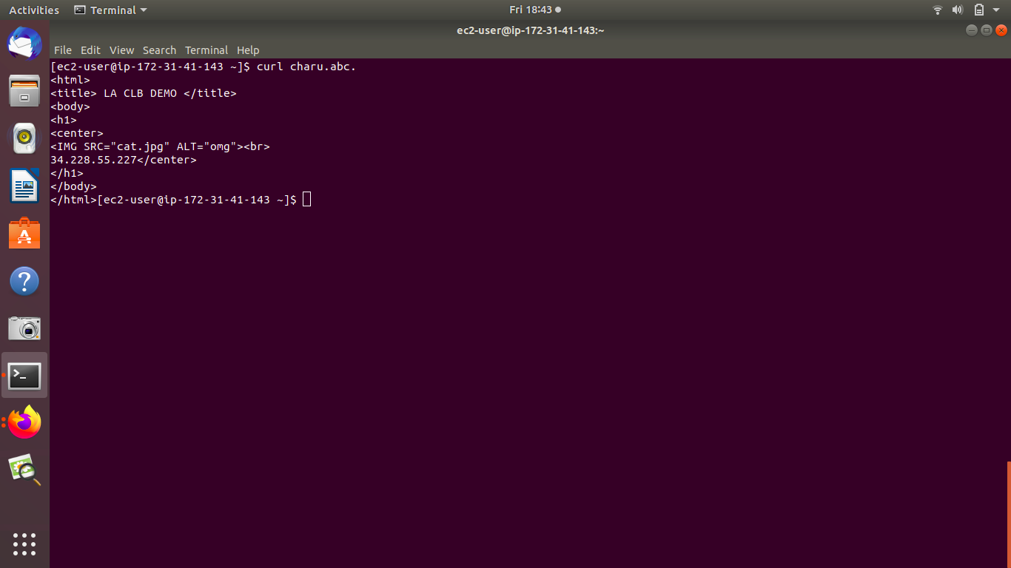

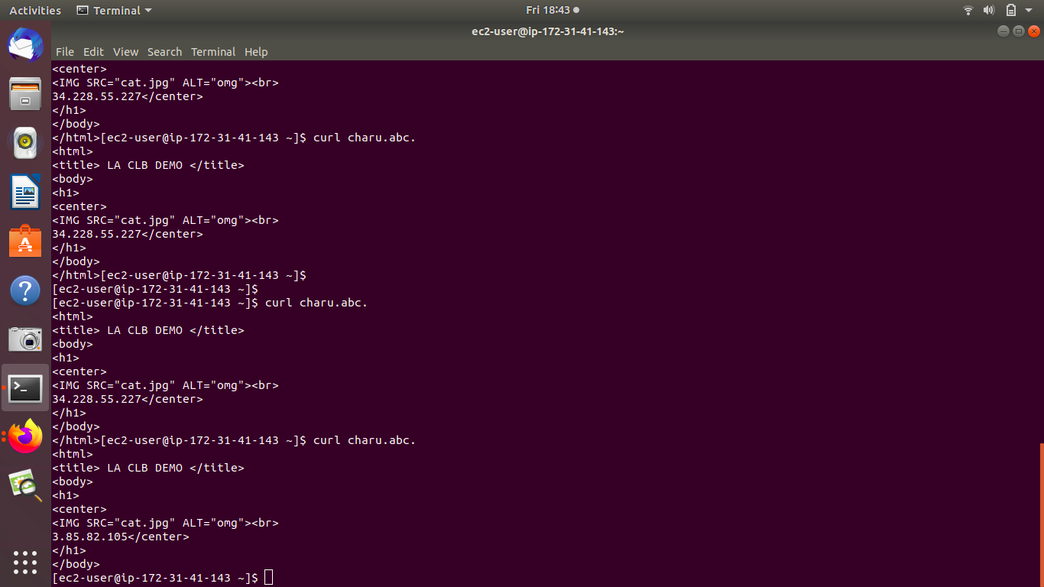

Create a non-public S3 bucket and give appropriate permissions to a server to download objects from the bucket but not to put or delete anything in it.

